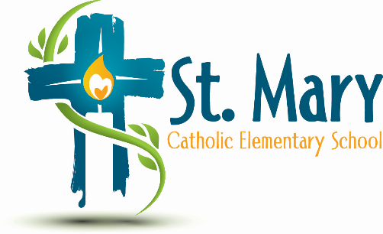
Administrator's Report
April 27, 2026
“People of Hope”

Celebrations:
- Flex Sessions

Information/Requests:
- Volunteer Appreciation
- Budget 2026/2027 - ECSD provides contingency funding to add 1 extra teacher to supplement low enrolment.
- I am Principal of only St. Mary next year.
- Dates for next year:
  - Will send a year at a glance in Sept.
  - Meet the Teacher
  - Family Dance
  - Christmas Concert
- GIST Program
- Climate Action Kits presentation (Carla Barnfather) – request for funds
- Table Hockey Sets – 3 new ones at $250 each
- Current Invoice

Upcoming Events:
https://stmary.ecsd.net/calendar#mobile-calendar-list

