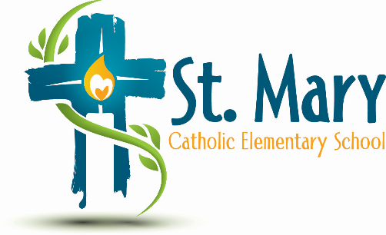
Administrator's Report
June 9, 2026
“People of Hope”

Celebrations:
- Government Allocation

Information/Requests:
- Christmas Concert – December 15, 2026 (We have chairs)
- Climate Action Kits Quote
- Request for 12 ipads (Students document learning)
- School Fees
- Final Invoice
- Next year’s approved fees & request for a special event budget
- Combined grades & class placements
Questions/Support for Societies:
Before you head off for summer, please take a few minutes to connect with your society chair/ treasurer to confirm the following steps have been completed:
- Have you filed your Annual Return with Corporate Registries?
- Is your AGLC Financial Review completed?
- Do you know when your next casino is schedule?
If your answer to any of the above questions is “no” or “I don’t know”, please email or teams Jolene.Thompson@ecsd.net for some support.

Upcoming Events:
https://stmary.ecsd.net/calendar#mobile-calendar-list

