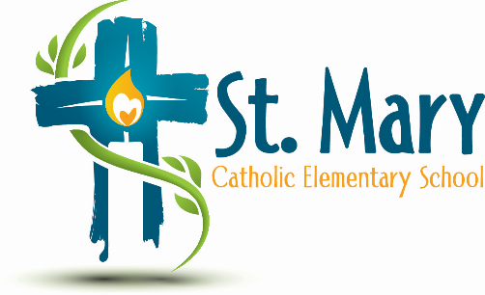
Administrator's Report
November 27, 2024
“People of Hope”

Celebrations:
- The November Review of the School Growth Plan demonstrates many successes in growth
- Alien In Line Skating went very well

Information:
- Teachers are doing reminders to bring in Raffle Basket items and even brainstorming but we are not getting many

Upcoming Events:
https://stmary.ecsd.net/calendar#mobile-calendar-list

