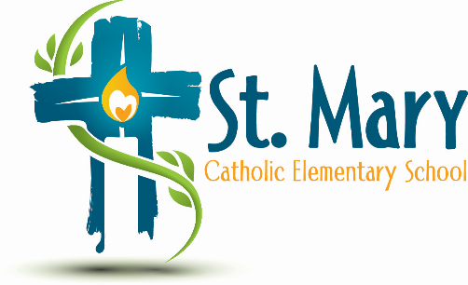
Administrator's Report
April 3, 2025
“People of Hope”

Celebrations:
- Les Bucherons
- Book Fair
- Shrove Tuesday pancakes & Ash Wednesday (Father Mark)

Information:
- We now have 12 families identified as “in need” - some new to the school.
- Chromebooks
- Kindergarten enrolment is at 43 (highest number in past 5 years at this time of year)
- Class sizes

Upcoming Events:
https://stmary.ecsd.net/calendar#mobile-calendar-list

