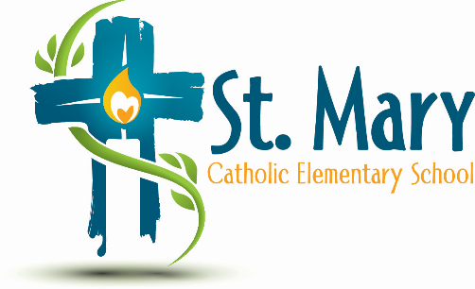
Administrator's Report
February 19, 2025
“People of Hope”

Celebrations:
- Open House – Kinder Open House
  - Well attended and positive feedback about our inclusive environment among other many things.
- Family Dance

Information:
- GST Financial Update – When invoicing in the future, we will use the Net GST amount.
- Artist In Residence this year – the dance programs are full and booking into next year. We will keep our eyes open for opportunities but do have Les Boucherons booked.
- Artist in Residence next year– Drumming Residence is booked for next year in the Spring. $6000 - $7000 for 6 to 7 days. We are trying to apply for a matching grant. Includes a finale performance that parents are invited to.
- We now have 9 families identified as “in need” - new to the school

Upcoming Events:
https://stmary.ecsd.net/calendar#mobile-calendar-list

