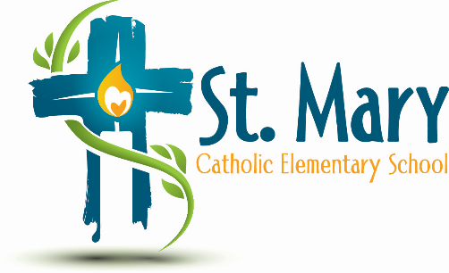
Administrator's Report
January 14, 2025
“People of Hope”

Celebrations:
- Christmas Concert
- Pancake Breakfast
Information:
- Artist In Residence – could inquire about a dance program this year. Or save the money and book the Drumming Residence next year. $6000 - $7000 for 6 to 7 days. Includes a finale performance that parents are invited to. We have filled out an application in case for between April and June next year (2026)
- Whole School Winter Activity – Les Boucherons – is a whole school but indoor FSL activity
- Swings/Picnic Tables Update
- Retention of Gaming Funds Form
- Playground Yearly Audit – No Action required (Educational Planning is responsible for all monthly and annual playground inspections. Furthermore, each spring and fall, maintenance is completed within your playground footprint to ensure students have access to a safe environment. Educational Planning will rectify any safety concerns which may have a high probability of occurring, such as tightening loose bolts; however, this does NOT include the replacement of equipment or the addition of Wood Chips and Sand that need to be topped up). Future Budget consideration
Upcoming Events:
https://stmary.ecsd.net/calendar#mobile-calendar-list

