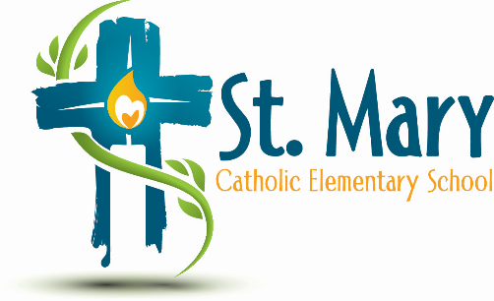
Administrator's Report
January 12, 2026
“People of Hope”

Celebrations:
- Progress towards School Growth Plan Goals

Information:
- Playground Audit – no action is required (everything is compliant).
  - Educational Planning is responsible for all monthly and annual playground inspections. Furthermore, each spring and fall, maintenance is completed within your playground footprint to ensure students have access to a safe environment.
  - Educational Planning will rectify any safety concerns which may have a high probability of occurring, such as tightening loose bolts; however, this does NOT include the replacement of equipment or the addition of Wood Chips and Sand that need to be topped up. If you need a top up, please contact us and we will get you a quote and estimated time for delivery.
  - If at any time the Division feels that equipment is unsafe, it will be removed.

Upcoming Events:
- Family Dance – Feb. 6?
- Shrove Tuesday – Feb 17 – Pancakes?
https://stmary.ecsd.net/calendar#mobile-calendar-list

