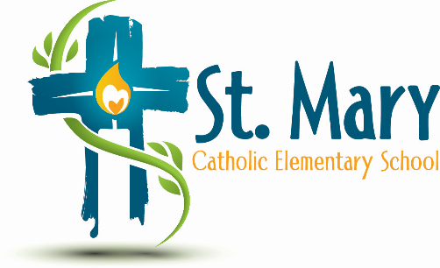
Administrator's Report
September 25, 2024
“People of Hope”

Celebrations:
- List of Clubs/Activities at St. Mary this school year
- Recovered couches look amazing – Thank you!

Information:
- Budget Update
- Current Fund Requests

Upcoming Events:
https://stmary.ecsd.net/calendar#mobile-calendar-list

