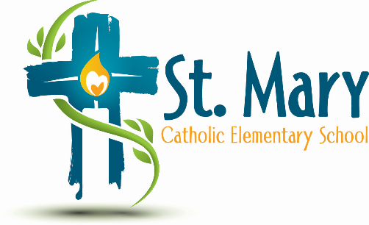
Administrator's Report
October 30, 2024
“People of Hope”

Celebrations:
- Carmen Leibel Project
- Art Cards Project

Information:
- St. Mary School Growth Plan
- Glow Team Requested a Family Picnic – Wondering if a Hot Lunch in June could be a Family Picnic?

Upcoming Events:
https://stmary.ecsd.net/calendar#mobile-calendar-list

