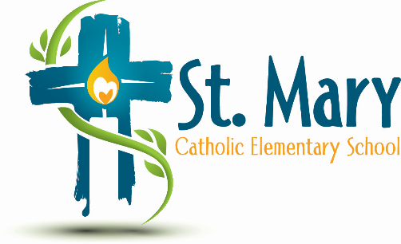
Administrator's Report
March 7, 2024
“Let Your Light Shine Forth”

Celebrations:
- Multiple Successful Projects and Events in the Month of February
  - Winter Carnival – Thank you for bringing in the Canadian Maple Shack, Lunar New Year, Social Justice (Mustard Seed Breakfast Bags), GLOW Family Dance, Random Acts of Kindess Week, Shrove Tuesday Pancakes, Ash Wesnesday Liturgy, Snow Valley Skiing, Pink Shirt Day and many more!
- Clubs are in Full Swing
  - Leadership
  - Table Top Hockey
  - Intramurals
  - Recess Club
  - Makerspace during Indoor Recess for younger grades
  - Volleyball

Assurance:
- School Growth Plan February Review

Information:
- March is Nutrition Month
  - What to consider for food at school
- ECSD Administrative Procedure
- Alberta Nutrition Guide for Schools
- Allergies – pg. 54 under taking action in the AB Nutrition Guide
- Respect and support parents role as providers for their children – pg. 13
- Creating undue hardship for families and contributing to a cutlture of an inequitable experience
- Alternatives for celebrating special days
- ECSD resource 1
- ECSD resource 2
Upcoming Events:
https://stmary.ecsd.net/calendar#mobile-calendar-list

