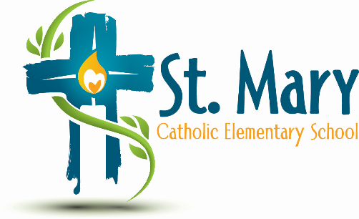
Administrator's Report
November 24, 2025
“People of Hope”

Celebrations:
- Literacy & Numeracy Data
Information:
- Budget Update
  - Our allocations are not large enough to fund our school. The Division provides us with contingency for teaching staff so that we can keep smaller numbers in the younger years. We do not have additional funds for extras such as reading intervention, etc.

- Confirmation of School Council Approved Items based on the August Proposed Budget.

Upcoming Events:
- Student-Led Parent/Teacher Conferences
- Music Concert Reschedule to Spring (Tentative Date – May 6)
  - Advent Celebrations throughout the month
  - Other activities in the last week of school include caroling on the last day. Does SC want to do pancake breakfast. Is there anything else that the Fundraising Committee wants to do or adjust how baskets are done?
https://stmary.ecsd.net/calendar#mobile-calendar-list

