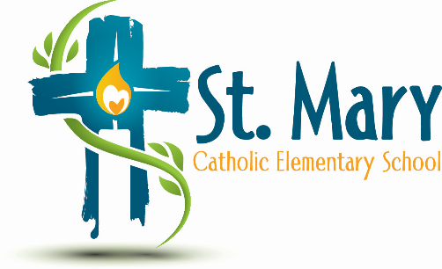
Administrator's Report
May 7, 2025
“People of Hope”

Information:
- School Fees – Same as last year with possible slight adjustment to user fee & subscriptions
- Budget – ECSD Contingency provided 1.5 teacher to supplement low enrolment
- Chromebooks
  - 164 Working chromebooks
  - Other schools experience with bring your own device 4-6
- School Growth Plan
- Dates for Next Year
  - Will send Year at Glance in September
  - Meet the Teacher is September 17 – AGM?
  - Family Dance – all Fridays in Feb are reserved for SC
  - Christmas Concert – Dec. 10

Upcoming Events:
https://stmary.ecsd.net/calendar#mobile-calendar-list

